AWS DEVELOPER ASSOCIATE :

Configuing aws CLI in local:

aws configure
give access key id, give secret access key
give region

aws iam list-users

EC2 Fundamentals:

- Create a EC2 instance and download the pem keypair file.
- Open terminal in the pem file directory.
- Run commands in EC2 instance connect section.
- To installl any we have to be root user. So enter sudo -i
- Jdk 18 installation:
https://computingforgeeks.com/how-to-install-java-18-on-centos-fedora/

Install an executable jar in EC2 instance:
- Upload jar to S3 bucket then go to Actions & get pre-assigned url.
- Now go to EC2 instance as a root user( sudo -i). wget -O name-of-jar “presigned url”
- java -jar JAR-NAME
- Add security inbound rule, Type -> Custom TCP, Port range(8080 -> your application running port), source -> 0.0.0.0/0.
- Take the public URL in the EC2 instance and hit via postman
To install mysql in EC2 server
- yum install -y mariadb-server
- systemctl enable mariadb
- systemctl start mariadb
- mysql_secure_installation
- mysql -uroot -p
Deploying the React Application:
- Create AWS EC2 instance.
- Install node in ec2 instance.
- Install git (sudo yum install git -y) and use node version 16
- Clone the project to the instance
- Run npm install to download the modules.
- Run npm run build and after run “serve -s build”

Observation: After creating an instance from an AMI(which contains both jdk 18 and mysql) and posting some data via rest api(aws_student_0.0.1-student.jar) to mysql database, then even is you stop the instance and restart it the data is being saved.

Elastic Load Balancing and Auto Scaling Groups:
Load balancers act as front wall which takes the traffic and distributes the traffic to the target groups(target groups are nothing but group of instances).
We talk about Application Load balancers which are mostly used for HTTP/HTTPS.
- Click on Create a application load balancer(ALB).
- Give a name to the ALB.
- Scheme -> Internet-facing and IP address -> IPV4.
- Mappings -> select all AG’s
- Select/create a security group which has inbound rules CUSTOM TCP, port range(8080 -> your application running port), source IPV4
- Listerns -> HTTP – 8080, Select a target group.
- Create a target group -> Choose a traget type as an instance.
- Give a name to the target group
- Protocol HTTP 8080 and Next
- Register target instances -> click all the instances that apply(attach the security group to the instances with inbound CUTSOM TCP -> 8080, source IPV4 OR if you don’t want anyone to direct access the instance but access via onlt ALB then update source IPV4 to security which is attached to your load balancer).
- Ports for the selected instances -> 8080
- Click on Include as pending below.
- And click on create a target group.
- Finally select the target group in ALB page
- Click on Create load balancer.

ROUTE 53
What is DNS?
A Domain name system which translates the human friendly hostnames into the machine IP addresses.

Record Types:
A -> Maps a ec2 insatnce IPV4 to a domain name. Ex: “test.thevishaldev.com”
AAAA -> Maps a ec2 insatnce IPV6 to a domain name. Ex: “test.thevishaldev.com”
CNAME -> Maps a hostname(load balancer) to another hostname(test.thevishaldev.com)
ALIAS -> Alias is used to point hostname to a AWS Resource. To use ALIAS we should select RecordType as “A”, click alias on, choose the aws resource, region.
Note: The important feature in ALIAS WE CAN point aws resource to the root hostname(“thevishaldev.com”)

Routing Policy:

Simple: Typically route traffice to a single resource. Its typically route traffic to a IPV4 or DNA name we provide at initial stage. If you provide multiple IPV4 addresses then client will pick random address and use one address.

Weighted: We can set how much percentage of time our DNS server should point to a instances. Instance 1 (70%) and Instance 2 (30%).

Latency: If one user is India and another user is in America. And one server are deployed in India and another server is deployed in america. User 1 who is in India will be redirected to India Server and user 2 who is in america will be redirected to America server. So users feels low latency.

Geolocation: Germany people should route to instance that deployed in germany which gives german version of application and india people should route to a instance deployed in india which gives india’s version of application.

VPC

VPC: Virtual private cloud is a private network to deploy your resources (regional resource).
Subnets: Subnets allow you to partition your network inside your VPC (Availability Zone resource)
A public subnet is a subnet that is accessible from the internet.
A private subnet is a subnet that is not accessible from the internet.
To define access to the internet and between subnets, we use Route Tables.

Internet Gateway and NAT Gateways

Internet gateway helps our VPC instances connect with the internet, public subnets have a route to the internet gateway.

NAT Gateways which is AWS managed allows the instances in the private subnets to connect with internet. NAT gateway routes via internet gateway to allow access to the private subnet instances.

What is Network ACL and Security groups
When we create a ec2 instance, in a default vpc, a default Network ACL is there, we never configured it, so it took the default configuration.

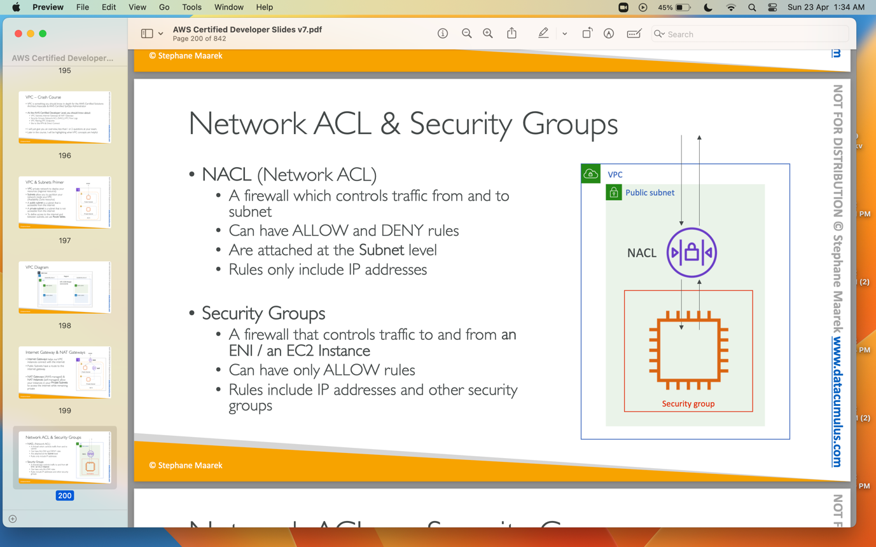

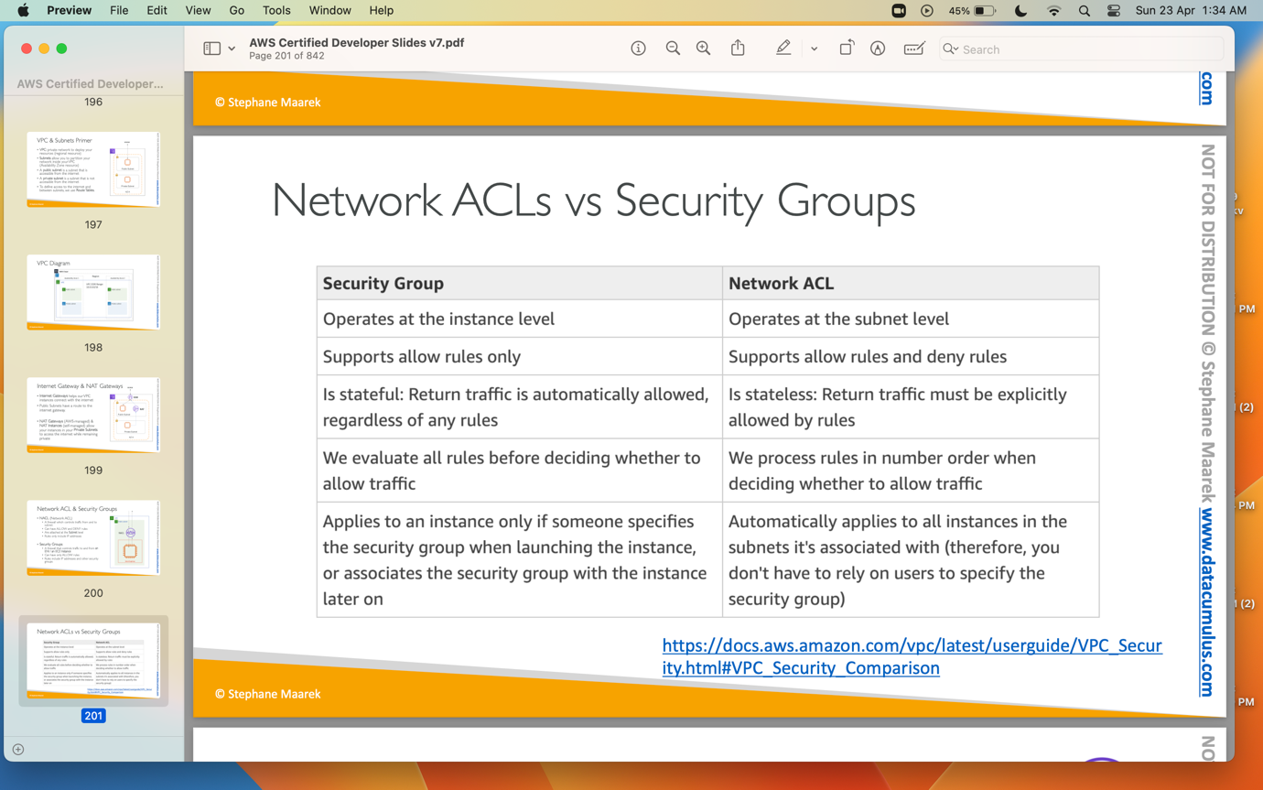

VPC Flow Logs: It is used to capture information about IP traffice going into your interfaces.
VPC Peering: Connect two VPC, privatly using AWS’s network.
VPC Endpoint: VPC endpoints allow instances in private subnets to connect aws services.
VPC Endpoint Gateway: S3 & Dynamo DB.
VPC Endpoint Interface: the rest AWS services.
Site to Site VPN: Connect on permsises datacenter to VPC
Direct Connect: Physical connect between on premises datacenter to VPC.

Amazon S3

Amazon S3 is very important service in AWS. It Is widely used service.
We have to create a bucket in S3 in order to use it. Bucket name should be unique in all aws service account level.
We upload any file into the s3 bucket, it is treated as object.

The key is the FULL path:
• s3://my-bucket/my_file.txt
• s3://my-bucket/my_folder1/another_folder/my_file.txt

The key is composed of prefix + object name
• s3://my-bucket/my_folder1/another_folder/my_file.txt

Making an S3 BUCKET public so we can access all files/objects inside the S3 bucket:

- Click on the permisions tab in s3 bucket and edit the block public access and uncheck the block public access checkbox.
- Create a S3 bucket Policy using policy generator, policy should be like below.

{
"Version": "2012-10-17",
"Id": "Policy1682247897459",
"Statement": [
{
"Sid": "Stmt1682247894513",
"Effect": "Allow",
"Principal": "*",
"Action": "s3:GetObject",
"Resource": "arn:aws:s3:::firstbucket392/*"
}
]
}

S3 Bucket versioning:
By Default S3 bucket is not enabled. Go to the properties tab and edit the bucket versioning to enable. Then try to delete a file. After deleting a file come to your bucket and toggle the show versions. You will see that your deleted file not deleted, it is still in the bucket and a versioning is added to that. Now delete the versioned file, your file which was deleted will be restored.

AWS CLI DRY RUN
We can use --dry-run command to test the command line api’s wheather we have permissions or not. If you wanna check wheather you can start an ec2 instance via command line but you don’t wanna really start ec2 instances, in that case we can add –dry-run in your command which prevent them to really start the ec2 instances.

AWS CLI STS DECODE
To debug an error message we can use this command in cli “aws decode-authorization-message –encoded-message <error value>”. This will give the detailed explaination of error message.

AWS SDK
If you want to perform actions on AWS directly from your applications code we need aws sdk. SDK stands for software development kit.

AWS ECS

Amazon Elastic Container Service (ECS) is a fully-managed container orchestration service that helps you run, deploy, and scale containerized applications on AWS. An ECS cluster is a logical grouping of Amazon EC2 instances or AWS Fargate tasks that run containerized applications.

Task: A set of one or more containers that run together on a single container instance.
Task Definition: A blueprint for a task that specifies the Docker image, CPU and memory requirements, networking, storage, and other configuration settings for each container in the task.
Container Instance: An Amazon EC2 instance that has the ECS agent installed and is registered to an ECS cluster. Container instances can host one or more containers.
Cluster: A logical grouping of container instances that can be managed together as a single unit.
Task Placement: The process of selecting the best container instance to run a task on, based on factors such as resource requirements, task definitions, and available capacity.
ECS Agent: A daemon that runs on each container instance and communicates with the ECS service to manage tasks and report status.
Fargate: A serverless launch type for ECS that allows you to run containers without managing the underlying infrastructure.
Service: A long-running task that ensures that a specified number of tasks are running and automatically replaces any that fail or become unhealthy.

Launch Docker containers on AWS = Launch ECS Tasks on ECS Clusters.

Difference between EC2 Launch type and Fragate Launch type

If you need more control over the underlying infrastructure, then EC2 launch type may be a better choice. However, if you prefer a simpler and more automated approach, then Fargate launch type may be a better fit.

Creating a ECS Cluster:
- Navigate to AWS ECS page.
- Click on cluster and click on create cluster.

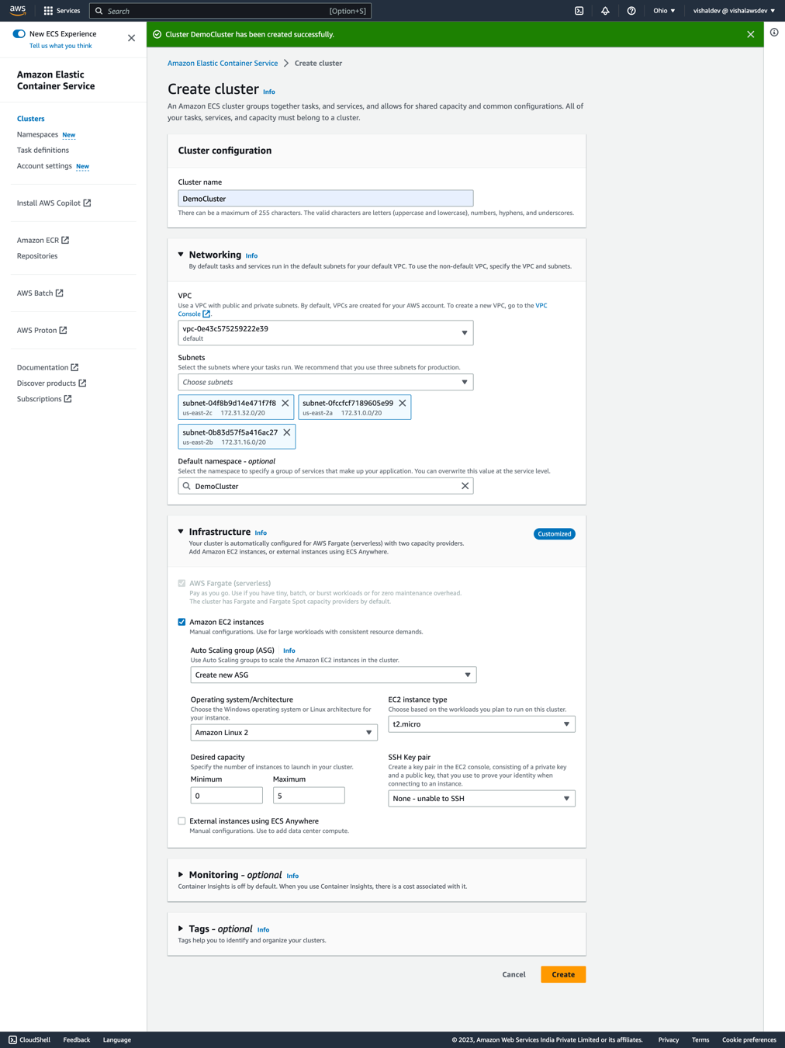

As we selected Amaxon EC2 instances, a new Auto scaling group will be created for you.

Creating a task definition
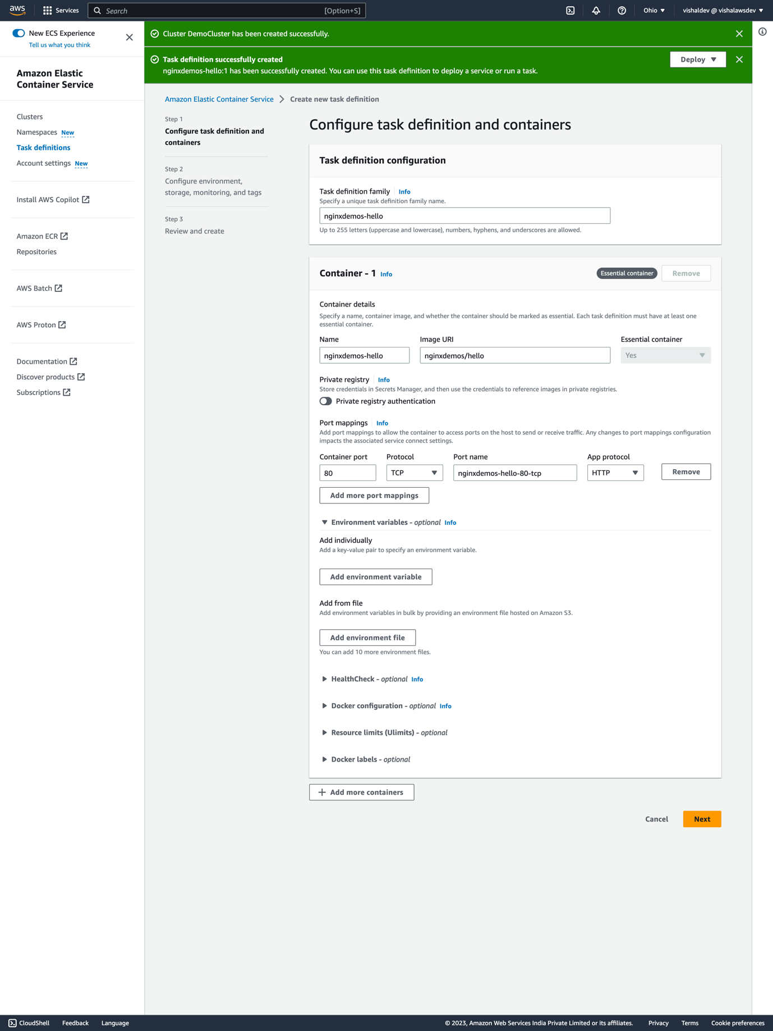
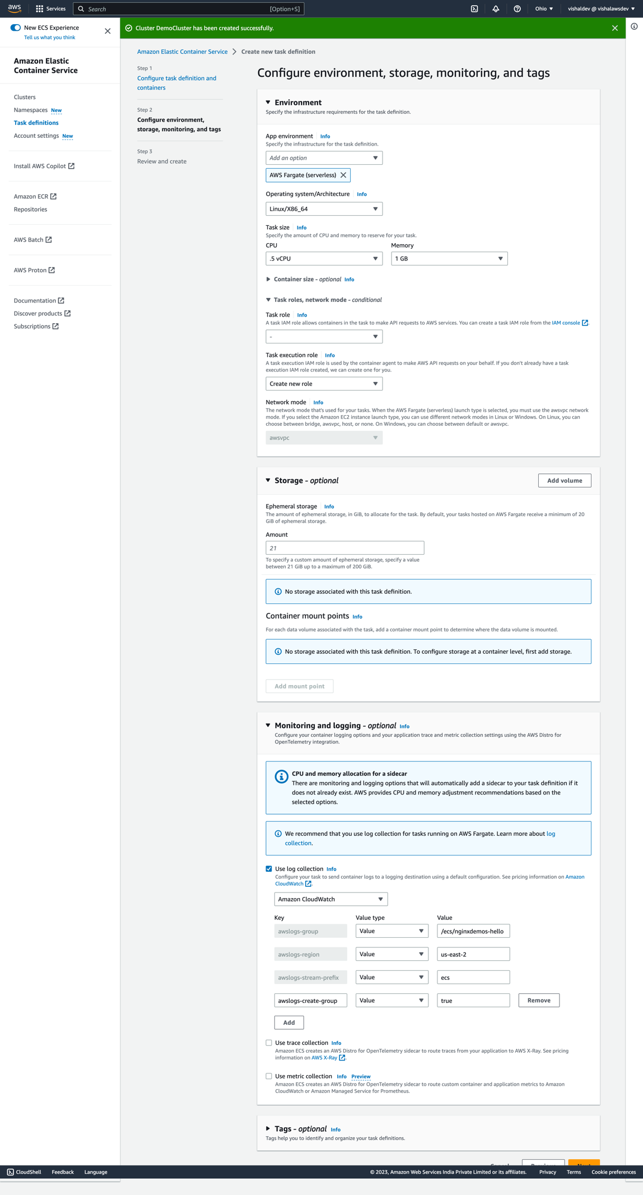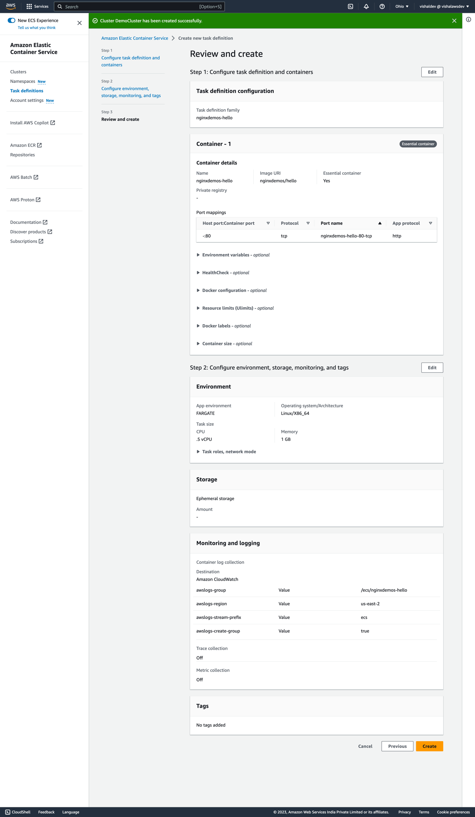
Creating a two security groups

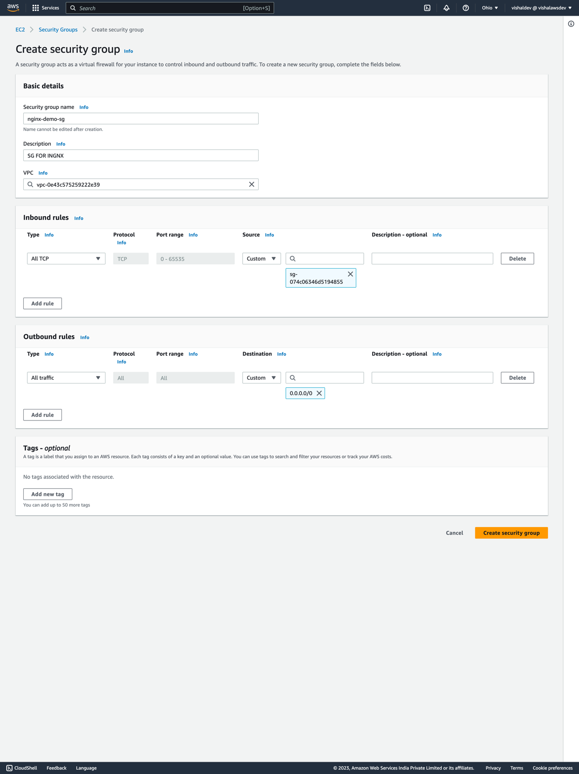

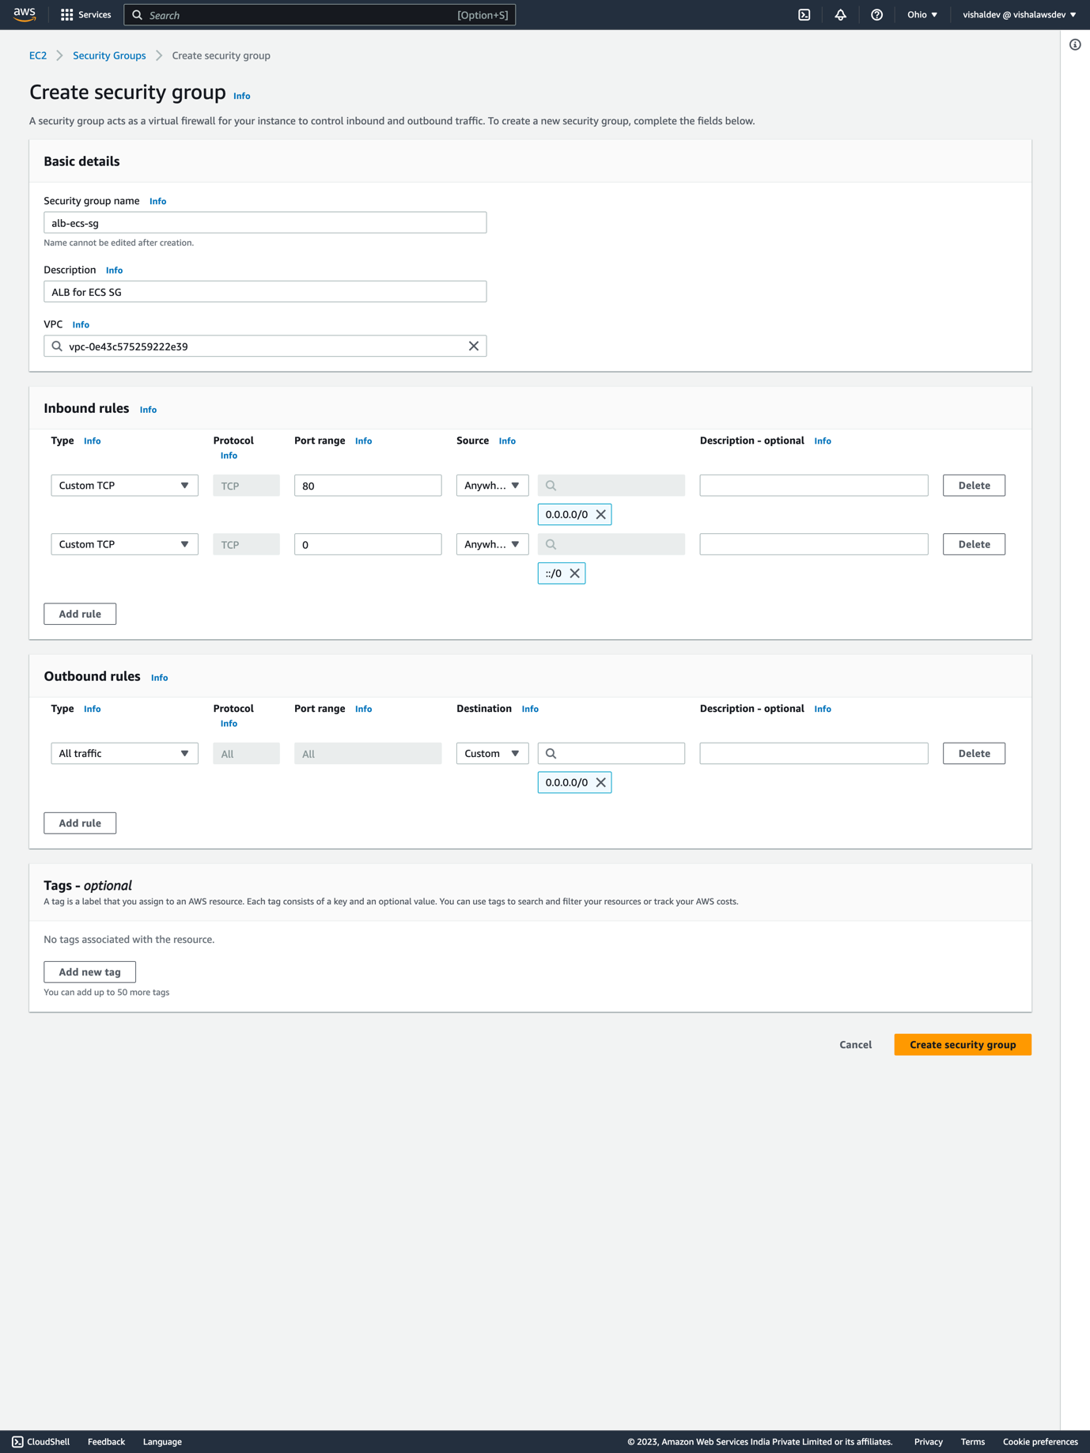

Creating a service

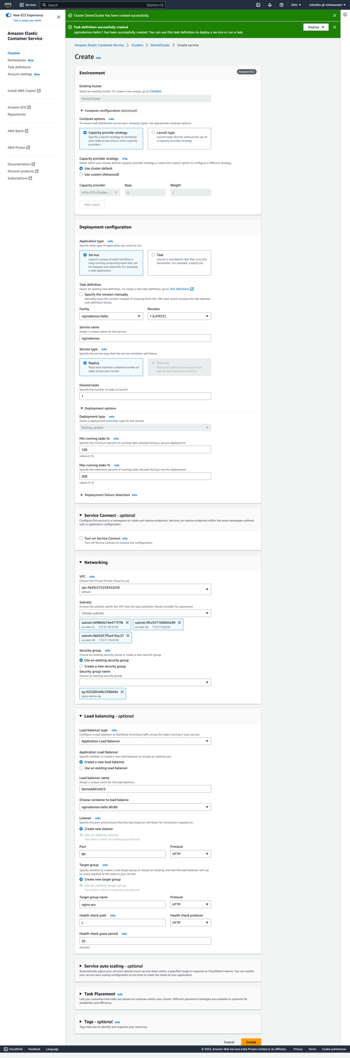
When you create the service, under the Compute Configuration section the Capacity Provider option is automatically selected to be the EC2 instance we created before. However, in this demo Stephane is using Fargate as the capacity provider. Therefore, you need to change Capacity Provider Strategy to be Use custom (Advanced) instead of Use cluster default. This then allows you to select Fargate as the capacity provider. I think he missed this step out of the video.

Note: in the above picture we selected wrongly the nginx-demo-sg, change to alb-demo-sg, we cant do that by going into the alb and edit the inbound rules.

After creating the service, go to the alb and copy the DNS and try hitting the url it should work.

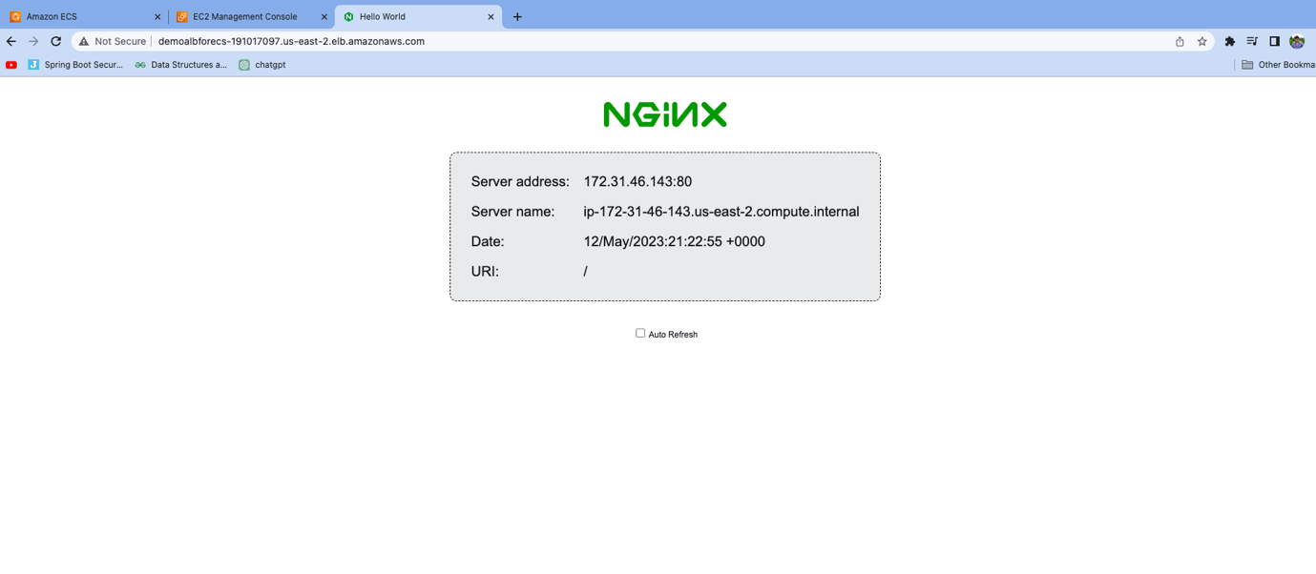

What is regions and Availability Zones?

us-east-1 -> reagion
us-east-1a , us-east-2a, us-east-3a -> Availability zones.

Aws Elastic Bean Stalk

